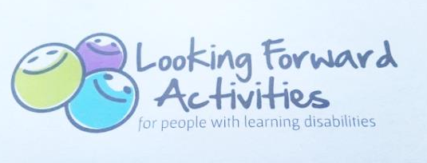
‘Looking Forward with Jude’ Drama Group: Fact Sheet

About the group
Jude Theatre Company CIC and Looking Forward Groups and Activities are working in partnership to provide a weekly 1 ½ hour drama workshop, during term time, for young adults with learning difficulties and disabilities living in Cheshire East. With the support of Cheshire East Council, we are able to offer this provision for FREE to those who are eligible.
Aims
This group aims to facilitate achievement and social development opportunities for the promotion of physical and mental wellbeing and independence.
Activities and Dates
Dates (week beginning) | Theme | Activity
8th Sep – 15th Dec 2014 | Raising confidence, exploring aspirations and developing employability skills | In-house performance of participant devised monologues as a group. Creation of an  individual achievement scrapbook, video or CV.
5th Jan- 30th Mar 2015 | Develop social skills and relationship awareness | Production of a number of short films exploring relationship boundaries and safety.
 |  | All projects will involve the opportunity to achieve AQA Unit awards
Day and Time
We have arranged two taster sessions to establish which day of the week and time will be the most suitable for participants and their families/guardians:

Taster Sessions
- Monday 8th September 1-2.30pm
- Wednesday 17th September 1-2.30pm
This group is open to all who are eligible and we welcome your thoughts upon the suitability of a variety of days and times.
Location
United Reformed Church, Antrobus Street, Congleton, Cheshire, CW12 1HE

Eligibility Criteria

The group will be run by professionally trained staff and volunteers with experience working with both drama and participants with learning difficulties and disabilities. The provision is therefore designed so support participants who:
- Have a learning difficulty and/or disability;
- Are aged between 18-30;
- Have independent personal care skills;
- Are able to demonstrate a level of understanding necessary for their development;
- Do not behave in a way which is likely to cause a risk to themselves, other members or staff.
If you feel a prospective participant has any additional needs beyond those listed above, please contact us to arrange an individual assessment for potential involvement.
Funding and Consent
The group is FREE to participants thanks to the support of the Cheshire East Council Adult Innovation Fund, therefore no payment is required. We do however require evidence of parent/guardian awareness of participation and emergency contact information.
Contacts
For more information about the group please call Helen on 07884434101 or email helenlees@judetheatrecompany.co.uk. You can also find out more about
Jude Theatre Company CIC @ www.judetheatrecompany.co.uk
and
Looking Forward Groups and Activities on Facebook

